** **

**Tollman Bouchard Finlayson Art Award**

**2015 Tondo Competition**

Information and Rules

The works of finalists will form the Tollman Bouchard Finlayson Barrel Head Exhibition.

These will be exhibited and on sale for the duration of

**Hermanus FynArts 05 – 16 June 2015.**

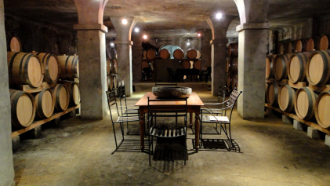

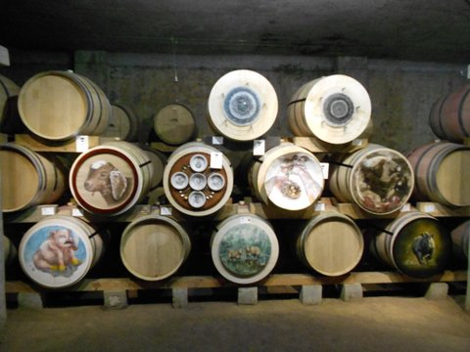

**A selection of 2014 winners and finalists**

**Prizes:** A winner’s prize of **R30,000** and 3 merit prizes of **R5,000** each.

**Theme:** *Connections*

**Format/Size: Tondo (round),**  maximum **60cms** diameter, including mount or frame.

**Media:**  *The following media will be accepted:*

Paper, canvas, board, Perspex, fabric, embroidery, collage, mixed media, photography, digitally/mechanically produced and photo-based.

**Presentation:** Works may be submittedframed or unframed. Unframed works must be suitably mounted on a firm backing as necessary. Works must be ready for display hanging vertically on the barrelheads. Artists must ensure that their full name and the title of the artwork are written clearly on a label on the back of each work.

**Entrance fee:** **R100** per work. There is no limit to the number of works per entrant.

*An additional fee of **R75** per work is payable if your artwork must be posted back to you.

**Commission:** A sales commission of **20%** will be payable to **Hermanus FynArts**.

**Exhibition:** The finalists’ works will be exhibited in the Bouchard Finlayson wine cellar until Dec 2015 unless the artist wishes to remove their work earlier.

**Postal entries:** Must be received by **15 May 2015**.

**To: Hermanus FynArts 2015 Art Competition, PO Box 1422, Milnerton 7435**

*A completed Entry Form must accompany all Postal entries. Postal entries must be insured by the entrant and delivery is at your own risk. The fee for Postal returns of unselected or unsold works is **R75** per work. If your artwork is sold and you paid a return postal fee, this will be refunded to you when payment is made.

**Payments:** Entry fees to be paid to:

**FYNARTS, ABSA Business Account, Account No: 40 8247 8568,**

**Reference:** **COMP** plus your **SURNAME** and **INITIALS.**

Proof of payment to be emailed to: [artcompetition@hermanusfynarts.co.za](mailto:artcompetition@hermanusfynarts.co.za) by **15 May 2015**

Cash payments only will be accepted when hand delivering your works.

**Drop-off:** The drop-off points to hand deliver your works and pay the Entry fees in Cape Town

and Hermanus are:

***Cape Town*:** Claremont Library from 10h00 to 15h00 on Thursday 14 May 2015

Wilderness Road, off Main Road

***Cape Town*:** Bellville Library from 10h00 to 15h00 on Friday 15 May 2015

Carel van Aswegen Street, off Voortrekker Road

***Hermanus*:** Hermanus Tourism from 10h00 to 15h00 on Thu 14 & Fri 15 May 2015

Station Building

**Collection:** Unsold artworks can be collected at (*unless you have paid a R75 postal return fee):

***Cape Town:*** Milnerton Library from 10h00 to 13h00 on Fri 26 June 2015

Pienaar Road, off Broad/Zastron Roads

***Hermanus:*** Hermanus Tourism from 10h00 to 15h00 on Thu 25 & Fri 26 June 2015

Station Building

**Judges:** **Marilyn Martin**, independent academic, writer and curator,**Louis van Heerden**, artist and teacher, and **Mandie Van Der Spuy**, arts consultant.

**Judging:**            Judging will take place between **25 – 29 May 2015**.   The judges’ decision will be final.

**Prize-Giving:** The prizes will be presented at an award ceremony, for invited guests only, at the

Bouchard Finlayson wine cellar, on **Friday 5 June 2015** at 12h00.

**Website:** [www.hermanusfynarts.co.za](http://www.hermanusfynarts.co.za)

**Email:** For further info: [lornajakins@iafrica.com](mailto:lornajakins@iafrica.com) or [artcompetition@hermanusfynarts.co.za](mailto:artcompetition@hermanusfynarts.co.za)

**Entry Form:** Print and complete an Entry Form.

**Indemnity:** All works are posted, submitted and exhibited at the owner’s risk. Hermanus FynArts and Hermanus Tourism do not accept responsibility for any damage to or loss or theft of any works, or for the failure of a prospective buyer to fulfil their obligation under the contract of purchase.